Tomb Raider 10th Anniversary Edition (PSP)

1. Introduction 2
2. Control 4
3. Camera and Collision 8
4. Combat and AI 8
5. Hazards and Triggering 9
6. Save Game 9
7. Co-operative Play 10
8. Multiplayer Trading/Unlocking 11
9. Viral Marketing 13
10. Front End and Inventory 14
11. Levels and Maps 14
12. Graphics and Animation 16
13. Difficulty and Tutorials 16
14. Audio 16
15. Design Methodology 17
16. Resources 17
Tomb Raider 10th Anniversary Edition (PSP)

Introduction
The original Tomb Raider was released in 1996, so 2006 will be the 10th anniversary. This document outlines a concept for creating a special edition of the original game for the PSP platform to coincide with this anniversary.
The concept is to provide players with a “re-mastered” hand-held version of the classic game. This should appeal to people who played it first time around, and those who missed out. Retro gaming has shown itself to be a lucrative market, and Nintendo in particular have had considerable success with versions of SNES titles on GBA and Mario 64 on the DS.
So the idea would be to build a new set of PSP Tomb Raider games based on the proven gameplay of the original game engine, but brought up to date using the additional power of the PSP.
Although the idea is to preserve the original gameplay and levels (albeit in a graphically enhanced form), additional Easter egg and bonus features are planned to add an extra dimension to this version. In order to finally satiate the fans lust for a multiplayer Tomb Raider, the plan is to include a 2 player cooperative mode by teaming up with Lara’s younger cousin Melissa Croft.
Feature Summary
The game will be a version of the original game, with the following enhancements:
  - Higher resolution textures.
  - More detailed geometry. The original geometry will be exported to Maya and updated to add detail.
  - Improved lighting. The original game had monotone lighting – the proposal is to add coloured lighting.
  - Replacement of sprites with 3D models.
  - Improved particle effects.
  - Full screen effects (blooming, focal blur).
  - Updated sound effects.
  - Fully skinned and detail Lara model.
  - Skinned and higher detail enemy character and creature models.
  - FMV sequences redone. Alternatively, it may be possible to resample the original sequences.
In addition to these cosmetic improvements to the original game, additional new features are planned:
  - Variations to original game. Slight tweaks to the original puzzle setups, or positions of bad guys to add surprise for people who remember the original.
  - New secret areas. These will be added to the maps and unlocked by special items collected on previous levels. They will contain the new outfits / weapons and rare collectables.
  - New extended ending. The original game ended very abruptly because of time constraints. It would be good to include the “escaping from the collapsing pyramid” sequence that was originally planned.
  - Tweaked controls: Smoother controls, and additional animations and moves (especially for combat).
  - Cooperative wi-fi mode. Two players get to explore the tombs as a team. Puzzles would be tweaked to require both players to work together e.g. heavy levers that require both girls to move. Additionally, players will compete over the collectables (see below).
  - Puzzle locks. Mini-game style puzzle locks to enter certain rooms.
  - Collectable artefacts scattered around the levels. So each tomb will be filled with treasure items, some more easy to find than others, and some more rare than others. There will be different classes of collectables, some of which can unlock new secret areas.
  - Trading. Treasures and special items can be traded with other PSP TR1 players. Each PSP’s unique ID will be used to randomly seed the player’s TR1 levels with a subset of the available artefacts, so for players to collect them all they will need to trade with friends. Additionally, in Wi-Fi coop mode, the levels would be seeded with items from both versions, so it is an opportunity to collect items that are not available in your version.
  - Treasure room. Back at Lara’s mansion, the treasure room will record which special items have been located and which are still to be found.
  - Unlockable weapons and outfits. Extra weapons that were in later games and new outfits for Lara can be found in the game.
  - Dynamic lighting. Including the introduction of flares from TR2.
  - Analogue control. Optional analogue control for movement.

Control
Lock on/Change Target
Sidestep/ Walk

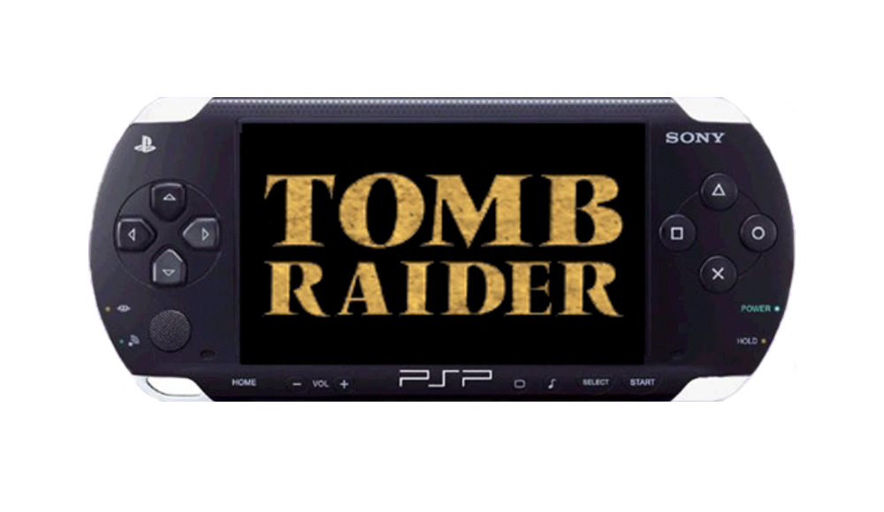
Direction Control

Draw

Action

Jump
Look Around
Roll
Pause/Stats
Lara’s Backpack

Direction Control:
Pressing Up – Moves Lara forward at a running pace.
Pressing Down – Makes Lara jump backward a short distance.
Pressing Left or Right – Turns Lara in the desired direction.

Analog Controller:
Use to look around the environment, tap the analog stick to re-centre the camera behind Lara. Alternatively, this could use could only be activated be pressing a ‘look’ button – normally it could be used for analogue control as in Free Running.

X Button: Action
Cross allows Lara to perform a variety of tasks depending on the situation, e.g. Press when Lara is near a wall to climb up, press when Lara is near a switch to make Lara pull it, Press when Lara’s guns are drawn to fire.

Square Button: Jump
Lara can jump in any direction to evade her enemies, press Square and Lara will jump straight up into the air. If you press a direction immediately after pressing Square Lara will jump in that direction.

Triangle Button: Draw
Press Triangle to draw Lara’s guns, if she spots something hostile she’ll point her guns at it.

Circle Button: Roll
Press Circle to make Lara perform a diving forward roll, she finishes up facing 180’, Handy for making quick turns.

L Button:
Hold down to allow Lara to walk forward, backward and to the left and right, whilst walking Lara won’t fall off any ledge. If you walk up to a ledge Lara will stop, when standing still pushing left or right allows Lara to sidestep in the desired direction.

R Button:
When Lara has her guns drawn, tap Right Trigger to make Lara lock onto an enemy, she will now point at the desired target awaiting the player to fire. If there are multiple enemies tap Right Trigger again to switch lock between them. (Note: We may be able to replace draw with this, thus freeing up the triangle button).

Select:
Press select to enter Lara’s backpack, this is where she keeps her weapons, ammo, health, save game and puzzle items.

Start:
Press start to pause the action and view how well Lara is doing on the current level, viewable stats include – Time Taken, Distance Run, Ammo Used, Saves Used, etc…

PSP Control Tweaks
An area of concern would be that the control scheme from TR4 would not be up to modern standards. However, it should be noted that many of the limitations of the original Tomb Raider games’ control are the result of the PS1 pad’s digital input. Until analog sticks became standard, the camera relative control that is used virtually universally nowadays was not an option.
The PSP is also mainly digital, with a configuration that is very similar to the original PS1 pads. Although it does have an analog stick, this has been found to have very limited sensitivity, travel and user feedback. It is also awkwardly positioned on the PSP unit. Consequently, it should be noted that most PSP games are choosing to use the digital pad for primary control.
However, the plan for TR PSP would still be to address as many of the shortcomings of the original Tomb Raider control scheme as possible. This would include:
- Current control set tweaked to provide more fluid movement.
- Additional moves added to match the TR7 move set.
- Combat system overhauled to use similar target relative movement scheme proposed for TR7 (see the section on Combat).
- Animation blending introduced to provide more responsive controls than the pure animation driven system.
- ‘Attractor system’ from Free Running used to provide better level markup.
The camera relative controls of Free Running would suite Tomb Raider very well, we have produced a test area to prove this.
Extra Moves
We could add some moves from later TR games but ones that won’t break the current map configurations:
Climb – could be added without any worries because the climbable walls have specific textures and can only be performed within specific areas.
Crawl – another easy move to implement, we could use this to allow access to hidden areas too.
Sprint – Tap X repeatedly when running to activate the sprint, works pretty much as it does in free running, running out after a while. When in combat mode X is used to fire, so no sprinting when fighting.
Corner Climbing – Allow Lara to climb around corners when shimmying, this won’t break anything on the whole, there may be a few specific areas but we can easily fix them.
Horizontal Poles – First we should simplify the controls to just holding X to stay on the pole, which keeps Lara swinging too. Release X to drop or tap jump to, well jump. We could use poles in none essential areas and also modify sequence jumps to include them.
‘Sweetening’ the TR1 Controls
In general, the controls need to be more forgiving (e.g. last chance grab to prevent most fatal falls), more fluid, and generally faster. Some of this can be taken from later TRs (e.g. Auto-lining the player up with locks and levers) and some from Free Running. We should also look at a few entirely new ‘moves’ which will not conflict with map design but will make the game feel more fluid and up-to-date (e.g. a running pickup anim for collecting objects while on the move). The extensive use of blending rather than link anims should help to make the control system more responsive.
It is also likely that we will use the ‘attractor system’ from Free Running to provide better level markup and give the player more leeway in control.
Map Control Rules from TR1
In order for the maps to work, we must stick absolutely to the map rules from TR1:
Vaulting & Climbing
- 0.25 blocks (1 click) Lara automatically steps up.
- 0.5 blocks (2 clicks) Lara vaults up when player presses ‘action’
- 0.75 blocks (3 clicks) Lara climbs up when player presses ‘action’
- 1 block (4 clicks) Lara jumps straight up and grabs if the player holds ‘action’
- 0.25 blocks (1 click) When in water Lara can climb out.
Note: All vaulting and climbing can be performed onto a sloping surface, but only if the angle is 0.25 (1 click) or less
Jumping Vertical
- 1.75 blocks (7 clicks) this is the maximum height Lara can jump straight up to grab.
Standing Jump Forward
- Standing Jump forward 1 block to land on the centre of the target block.
- Standing Jump forward 2 blocks to grab the edge of the target block.
Running Jump Forward
- Running Jump forward 2 blocks to land on the centre of the target block.
- Running Jump forward 3 blocks to grab the edge.
Back Flip
- Lara can back flip 2 blocks.
Side Flip
- Lara can side flip 2 blocks.
Sliding
- Anything on or above 0.75 blocks (3 clicks) will cause Lara to slide.
Shimmy
- Anything on or below 0.25 blocks (1 click) sloping edge can be shimmied along.
180’ Roll
- Lara always rolls across 1 block when she 180’ rolls, this is to allow her to climb onto a block and quickly turn to face the opposite direction ready to perform a running jump.
Tapping forward on D-Pad
- Lara steps 0.75 blocks forward and stops.
Tapping back on D-Pad
- Lara performs a small jump back from the front of the block to the back, placing her in the perfect position to run and jump from the edge.

Camera and Collision
The present Free Running camera is generally pretty good, and it is also likely that the TR1 camera would have to be ditched anyway because it relied on the AI box system (which will disappear if the collision becomes non-grid-based).
There could also be a secondary camera system designed specifically for trap areas. Basically you hold R-Trigger when your guns aren't drawn, now the camera stays behind Lara and acts more like the original TR cam, now Lara can sidestep, side jump, roll and pull off all kinds of crazy manoeuvring that would be much harder in the regular control system. The player can release the R-Trigger to return to regular control and camera.

Combat and AI
Two of the things that made the combat unsatisfactory in the previous Tomb Raiders were automatic locking-on and unlimited ammo.
The automatic lock on and firing would be replaced by a system where Lara has to actually press a button to lock onto a target, and must press that button again to cycle between targets (this was implemented in TR 4 or 5 but was relegated to an optional control rather than being the default). This method forces the player to be actively responsible for targeting on enemies, and is thus more rewarding.
We will experiment with removing unlimited ammo. This would require at least one of the following adjustments:
  - There would need to be respawning ammo pickups in the level. This was used from TR3 onwards for specific level-essential ammo (such as crossbow bolts that were used for solving a puzzle) but this idea could be extended to normal pistol ammo (so Lara can always get more ammo, but it might mean going back someway through the level.
  - Lara would need a close range attack such as a kick, punch or pistol whip. If we have close combat, we will also need to experiment with using a Zelda style lock on baddies, so Lara rotates around the enemy whilst firing
We could also experiment with forcing the player to reload (possibly using the ‘draw weapon’ button).
We will also use the baddies from later TRs (though textured/modelled to look like the correct animal for TR1), and extend their abilities in terms of where they can get to on a map. There were quite a few tweaks and improvements in the AI over the course of Tomb Raiders 1-5 so we will use the later code as a basis. If the collision maps end up not being grid based then we will need to use navmeshes instead of the box system used for AI route finding in the old Tomb Raiders.

Hazards and Triggering
Traps need to be exported from old TR with everything setup, including anims and how they are triggered. Obviously all of the animations will eventually be updated, but we need to get the traps working from day one. A complete list of the traps/hazards that need recreating are in the appendices.
We should also look at making the traps non-lethal where possible. Instant death is less acceptable in modern games, and for many of the traps it would be an easy fix to put in a last-chance grab or something similar to make the game more forgiving.

Save Game
We will not totally remove the save game crystals for the PSP, as this would greatly dilute the game play (because the player would be allowed to save the game as often as they liked). It would also remove the tension that was present in TR1 as you searched for the crystals and the joy when you found them.
Instead we would keep the blue crystals from the original game, maybe adding a couple here and there if we think it’s necessary, and also adding another smaller green crystal that can be found in smaller hidden places and are collected in the normal fashion, the green crystals are a ‘save anywhere’ type and are placed in the inventory until the player feels he needs to use one.
The player is given a fixed number of green crystals at the start of each level, which would initially be high and then reduce as the game progresses, after a level has been completed any spare green crystals are taken from the player and can be traded for either health or ammo, no crystals are carried over, allowing for easier difficulty level balancing.
This method would keep the tension of the original but still allow some degree of ‘save anywhere’ without ruining the dynamic of the game. The player would still take care when using a green crystal because they know there is a finite amount, tie that in with the possibility of being rewarded for not using the green crystals and the player isn’t going to want to waste them.
Another possible feature would be a “Save and Quit” save at any point which allows the player to save the game anywhere but which is erased when the player reloads it. This allows the player to save the game because the doorbell rings or they need to get off the bus, but prevents save game abuse. However, the fact that the PSP has a ‘hibernate’ mode means this may not be necessary

Co-operative Play
The first thing we should do is get two Lara’s dropped into the 1 player game without any modifications and allow a 2 player Wi-Fi link, simply to test how much fun it would be. This is the very basic form of cooperative play and wouldn’t take too long to implement.
Next we add extra new cooperative elements such as a different looking secondary character (Melissa Croft, Lara’s younger, sexier, but slightly dodgy cousin), separate inventories for each player would promote them to fight for the treasure, ammo, puzzle and health pickups. Trading between the two inventories would also allow the two players to swap different items depending on their circumstances i.e. player 1 has loads of medi-packs and no ammo, player 2 has loads of ammo and no medi-packs, so they trade. Everybody’s happy.
Now we change existing puzzles without changing the geometry or puzzle setup, push-able blocks require both characters to push them, pressure pads now require both characters to stand on them, large levers require two people to shift them, etc.
The next phase of co-op mechanics would be actual map changing specifically for the co-op adventure, this could be localised to rooms within the room system and could act as a co-op only flip map. For example:
Rich and Tom are standing before a high wall with a pressure pad directly in front of them; Rich stands on the pressure pad, which opens a door around the corner.
Tom goes through the door and up a flight of stairs.
Rich steps off the pressure pad and tries to run through the door, it closes again. He returns to the pressure pad area.
Tom is waiting above the pressure pad on top of the wall, when rich gets close to the pressure pad Tom gets a prompt on his screen that says ‘Press X to pull player 2 up’
If he presses X we are presented with a small cutscene of Tom helping Rich up onto the wall. It is possible that ‘cutscene’ will actually be a linked anim with a simple camera cut to mask any ‘snapping’ of position or rotation.
Note: The one player version of this example simply required the player to push a block onto the pressure pad, allowing the door to stay open; all we’ve done is remove the block.
This allows us to add extra puzzle bits to the levels without breaking the original 1 player game. It should be noted that it doesn’t matter if the 2 player game is somewhat different to single player – for instance, allowing one player to give the other a leg-up and then being pulled up may allow the player to reach higher than the 7-click maximum they can get to on their own. As long as this doesn’t create bugs, it’s okay if it allows the players to bypass one or two puzzles that they would otherwise have to face in the single player game.
There are also other types of multi-player interaction which are fun without being directly co-operative – e.g. if a boulder comes rolling down a slope and there’s only one alcove to hide in, and that isn’t being enough for both players, then one player is going to have to find some other way of escaping (and fast!).
There will also be occasions where one player will provide covering fire taking out enemies while the other player opens a puzzle lock or pulls levers to get a door open.
In treasure rooms the players will be actively competitive trying to get to the treasure first. Although we don’t want the players actively trying to kill each other, the levels could be designed in such a way that they can slow each other down.
Although it’s a completely different sort of game, the most recent 2D Zelda on GameCube uses this co-operative/competitive style very effectively (with up to 4 players). They use many of the mechanisms that we have already proposed (such as needing more than one person to push a block, and needing people to be standing on pressure pads in different rooms to open a door) but it would be worth going through the game in detail to look at their co-operative puzzles, even though the 3D environment of Tomb Raider provides us with many more possibilities.

Multiplayer Trading/Unlocking
Tomb Raider 1 had many items in the levels that looked collectable but weren’t, in TR: TAE we could allow the player to collect them along with many other items too, some items being invisible apart from a small glint when the light catches them, these items are valuable to Lara.
Even though they are none essential to finishing the game the antiquities are grouped into collections based on where they were found and what they are, there could be a collection of roman coins for example.
Each time a level is completed the player is given the option to return to Lara’s mansion and drop off the antiques they have accrued in the level, they will appear in display cases inside the treasure room. Empty cases hint to the player that other collections are to be found if they look hard enough, and empty positions within a display case show the player how many items there is in that collection.
Because it is unlikely that two players will go through the whole game in co-operative mode, the single-player game should unlock the equivalent co-operative level once that level is complete. This allows players to play a single level in co-operative mode once that level has been unlocked.

World Raider Tombs
Completing an antiques collection unlocks a secret ‘World Raider’ hidden tomb. The tombs have different themes depending on difficulty and skill, these are: Trap Tomb, treasure Tomb, Combat Tomb. Each proper level (or area) of the game has a World Raider Tomb equivalent. It is also possible that we’ll unlock one-off tombs from other famous areas of antiquity.
The Player doesn’t have to find all of the pieces to a collection to unlock a World Raider Tomb; they can trade spare pieces with other PSP users to get the ones they need. The logic could be done something like this –
Tom has most of the antiques to unlock Peru World Raider Tomb 1 and only needs one more piece. He also has a couple of pieces for Egypt World Raider Tomb 3.
Rich has only a few pieces of the Peru collection but has most of the pieces for Egyptian World Raider Tomb 3; he needs three more pieces to unlock it.
Tom asks Rich if he wants to trade one of his Egyptian pieces for the Peru piece he needs, Rich being a bit greedy declines the offer.
Tom now asks if all three of the Egyptian pieces will do for the one Peru piece, Rich agrees and the items are traded.
The key thing about trading is that the items remain unique to a players save game, for example – Now that Tom has traded the Peru piece he won’t be able to collect it again in his version of the game, because it’s already been collected and traded, the only way he can acquire this piece is by trading it back from another PSP player. This means that depending on how each individual player progresses through the game they will unlock different World Raider Tombs.
Another system, which could be used either instead of or as well as the previous system, would be to allow temporary unlocking of features depending on the combination of items that the two players possess. For example, I have a number of shards of an impressive Grecian urn, but not the full thing. You also have an incomplete urn, but between us we have all of the pieces of it (probably plus some duplicates). Neither of us individually has access to the Angkor Wat treasure room, but it is unlocked for us while we share a wi-fi connection so we can play a co-operative (or competitive!) treasure hunt in there.
Many other unlockables are also possible in the game, such as unlocking extra weapons or outfits. We should also allow the player to play the game through single-player with Melissa Croft once they’ve completed it with Lara.

Viral Marketing
This technique should be considered for TR:TAE It is a way of trying to use purchasers of the game to distribute demos of the game and encourage others to play it.

- The game allows the player to create a playable demo of the game (which only has a small subset of levels/content) onto a memory stick provided by another PSP owner.
- When they start up their demo game, some of the items in the game are created using the unique ID of their PSP… some of these items will not be available in the main (non-demo) game, and there is a possibility that they might be quite rare.
- These items can be traded (potentially back to the person who owns the original game)… the player would have to play for a while to get these items.
- The demo save game can be loaded into the full game – so if the player of the demo buys the full game they can continue from wherever they got to in the demo.

This means that owners of the game have an incentive to give away demos of the game, because they might get something out of it. There is also the lottery ticket aspect that you have no idea what items any particular PSP will produce until you put the demo on it and play the game.

Notes:
- “items” is used here as a cover-all name for anything of value or interest in the game, and is not limited to inventory items.
- I think that actually putting the demo onto a memory stick is the ideal way forward because the player can then take it away with them and get hooked on the game at their leisure. It would be even better if the demo could itself spawn demos, but this might present technical difficulties. However, the concept would still work if the game could spawn a multiplayer game over Wi-Fi
- Obviously we would need to find out from Sony very early on if this sort of thing would be allowed.

Front End and Inventory
Although many improvements have been made to the TR front end and inventory over the years, many people are still attached to the original ‘carousel’ front end and inventory. As a front end this is possibly a bit minimalist for a modern game, so the proposal is to have a front end which pays homage to the original TR front end, for example by having the items laid out on a table at which Lara is sitting and having the camera spin round to focus on each item as you move the d-pad left or right.
The in-game inventory should be based on the original TR, while including many of the enhancements that were made over the entire TR series (such as shortcuts for the most common inventory actions)

Levels and Maps
The idea is to preserve the original levels (albeit in a graphically enhanced form), with additional secret areas and treasure rooms. The proposal would be to revisit all areas of the game engine to see what improvements could be made. The geometry built in Maya rather than the simple TR editor based on the original level maps. The collision would remain largely unchanged but could be modified in areas where we were certain it would not break the gameplay.
Static Objects need to be exported from the old TR maps with instancing already set up and basic collision, and flip maps need to be exported from old TR fully with triggers intact. We will investigate using the technique of later TRs, where rooms could be individually flipped rather than the universal flipping on and off which took place in TR1 (and led to some very convoluted triggering).

We will also use coloured lighting and light states for certain rooms, similar to flip maps but with flipped lights, so you could set up a blend type between the two light states, good for creating flickering lights without the need for dynamic light.
For the levels, there will be a general tidying and improvement in terms of new, better textures and removing some of the worst aspects of blockiness. Some areas will be further improved, and particular “spectacular” points of the map will be given the most attention in terms of graphic reworking. We are currently identifying which areas in each level to concentrate on. Here are a couple of examples:
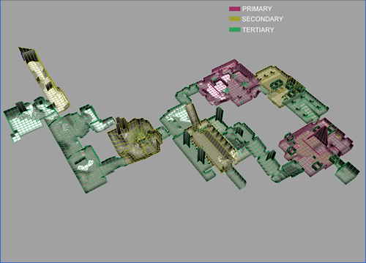
Peru Caves – The Key Primary areas being the Bridge and the Overgrown ruins.

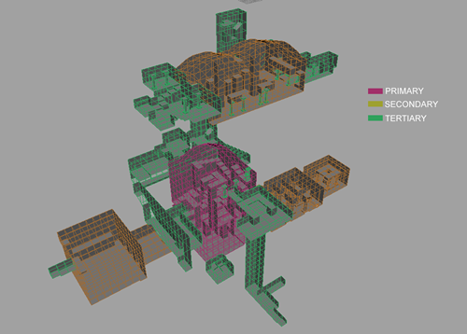
St. Francis’ Folly – The main ‘shaft’ area is the primary area.

Graphics and Animation
The game will based on the original game, with the following enhancements:
  - Higher resolution textures.
  - More detailed geometry. The original geometry will be exported to Maya and updated to add detail.
  - Improved lighting. The original game had monotone lighting – the proposal is to add coloured lighting.
  - Replacement of sprites with 3D models.
  - Improved particle effects.
  - Full screen effects (blooming, focal blur).
  - Fully skinned and detail Lara model (depending on which version of Lara we decide to use)
  - Link anims replaced with blending
  - Skinned and higher detail enemy character and creature models.
  - FMV sequences redone. Alternatively, it may be possible to resample the original sequences.
  - Use ragdoll physics for Lara

Difficulty and Tutorials
The game needs to be easier in general (for modern, particularly US tastes) and we will need to extend the tutorials to cover any new moves. As well as making the game more forgiving (by using things such as last-chance grab), we can add context-sensitive control help in early levels in the same manner as Free Running (either giving the player help in particular points on the map, or supplying feedback when they do something wrong).

Audio
Nothing major to do here… update some of the sound effects, put floor material sound effects in (as in later TRs), keep original music. The only possible problems are: Lara’s voice and VOs for FMV, new voice stuff for Melissa (it would be nice is there was some “chat” between the two Crofts).

Design Methodology
Take the existing Tomb Raider 1 design, then add new aspects to the game but in a modular fashion so that we can finish the game at any point without breaking it. This applies to the overall game design in terms of adding new features as well as the reworking of the actual levels from Tomb Raider 1.

Resources
Timeline
The installed base for PSP units in early 2006 is predicted by Sony to be in the region of 5 million units. Sales of a PSP Tomb Raider would therefore likely be in the region of 250,000 – 500,000 units assuming an attach rate of 5-10%.
So, due to the limited sales potential of the title on a relatively new platform, the project scope would need to be limited to allow a small team to turn around the game in a short time period.
The current plan is therefore for Tomb Raider PSP to ship Q2 2006.
Team
Expectation is that team size would be an average of 15 people (peak 20) over 10-12 months.
An additional full-time programmer may be needed. Also, 5-10 more artists would be required depending on the scope of the project.

